Address Resolution Protocol (ARP) Configuration in LAN using Cisco Packet Tracer

S.NO | REG .NO | NAME
01 | 2460624 | JOSEPH PADYATTY
02 | 2460626 | VISHUN K
03 | 2460629 | KAVINRAJ S
04 | 2460631 | KHUSHI PRAKASH BADLI

Abstract
Communication in a Local Area Network (LAN) requires translation between logical addresses and physical addresses. Internet Protocol (IP) is used to identify devices logically, while Media Access Control (MAC) addresses are used for actual data transmission at the data link layer. Address Resolution Protocol (ARP) is responsible for mapping an IP address to its corresponding MAC address. This paper presents the design and simulation of a LAN using Cisco Packet Tracer consisting of eight personal computers connected to a switch. The network is configured with static IP addresses, and communication between devices is verified using the ping command. The simulation demonstrates the ARP request and ARP reply process, as well as the formation of ARP tables in each device. The study provides a fundamental understanding of ARP operations in LAN environments and helps students visualize network communication processes.
Keywords
Address Resolution Protocol, LAN, Cisco Packet Tracer, Networking, IP Address, MAC Address, ARP Table
1. Introduction
In computer networks, devices communicate using logical addresses known as IP addresses. However, actual communication within a Local Area Network (LAN) occurs using physical addresses called Media Access Control (MAC) addresses. Therefore, when a device wants to send data to another device in the network, it must determine the MAC address corresponding to the destination IP address.
Address Resolution Protocol (ARP) is used to resolve this issue by mapping IP addresses to MAC addresses. ARP operates between the network layer and the data link layer. When a device needs to communicate with another device, it sends an ARP request broadcast message asking which device owns a particular IP address. The device with the matching IP address replies with its MAC address. Once the mapping is discovered, it is stored in the ARP table for faster future communication.
This paper demonstrates the working of ARP by constructing a LAN using Cisco Packet Tracer with eight PCs connected to a switch. The experiment helps students understand how ARP functions in real network environments.

2. Problem Statement
In a Local Area Network, communication between devices requires knowledge of both IP addresses and MAC addresses. While IP addresses are used for logical identification, MAC addresses are required for data transmission at the data link layer.
When a device wants to send a packet to another device, it usually knows the destination IP address but does not know the corresponding MAC address. Without this information, communication cannot take place.
To solve this problem, the Address Resolution Protocol is used. The objective of this work is to simulate ARP functionality and observe the ARP request and reply mechanism using Cisco Packet Tracer.
3. System Design
The proposed network is designed using Cisco Packet Tracer simulation software. The network consists of eight personal computers connected to a single Cisco 2960 switch using copper straight-through cables.
Each computer is configured with a unique IP address within the same subnet. The network uses a subnet mask of 255.255.255.0, ensuring that all devices belong to the same network.
The topology used in this experiment is a star topology, where all devices communicate through the central switch. This configuration allows easy observation of packet flow and ARP communication.

4. Network Configuration
The IP addresses assigned to each computer are shown below.
Device | IP Address | Subnet Mask
PC0 | 10.1.1.1 | 255.255.255.0
PC1 | 10.1.1.2 | 255.255.255.0
PC2 | 10.1.1.3 | 255.255.255.0
PC3 | 10.1.1.4 | 255.255.255.0
PC4 | 10.1.1.5 | 255.255.255.0
PC5 | 10.1.1.6 | 255.255.255.0
PC6 | 10.1.1.7 | 255.255.255.0
PC7 | 10.1.1.8 | 255.255.255.0
All devices are connected to the switch using Ethernet cables. Since they are in the same subnet, no router is required for communication.
5. Methodology
The experiment is performed using the following steps:
First, Cisco Packet Tracer software is opened and a new workspace is created. A 2960 switch and eight PCs are added to the workspace. Each PC is connected to the switch using copper straight-through cables.
Next, each computer is configured with a static IP address through the desktop IP configuration settings. All computers are assigned addresses within the 10.1.1.0 network.
After configuration, connectivity is verified using the ping command from one computer to another. For example, PC0 sends a ping request to PC4 using the command:
ping 10.1.1.5
During this process, the ARP protocol is triggered automatically. The sending device broadcasts an ARP request asking which device owns the destination IP address. The correct device replies with its MAC address, allowing communication to occur.
Simulation mode in Packet Tracer is used to observe the packet flow, including ARP request packets, ARP reply packets, and ICMP ping packets.

6. Working of ARP
The working of ARP can be explained in three main steps.
First, when a device wants to communicate with another device, it checks its ARP table to see if the MAC address corresponding to the destination IP address already exists.
If the mapping does not exist, the device sends a broadcast ARP request message to all devices in the network. The message asks which device owns the specified IP address.
The device with the matching IP address responds with an ARP reply containing its MAC address. The requesting device stores this mapping in its ARP table and uses it to send Ethernet frames directly to the destination.
This process ensures efficient communication between devices in a LAN.

7. Results and Observations
The simulation successfully demonstrated the working of ARP in a LAN environment.
When a ping command was executed between two computers, an ARP request broadcast packet was generated. The destination device responded with an ARP reply containing its MAC address. After this exchange, the ICMP echo request and echo reply packets were transmitted successfully.
The ARP table on the sending computer was updated with the IP-MAC mapping, allowing faster communication for subsequent transmissions.

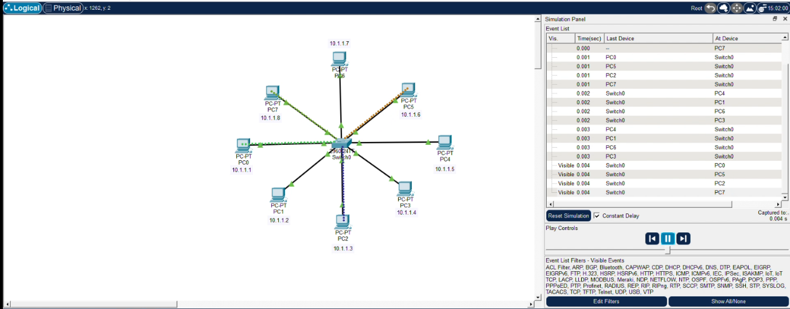

This image shows the Event List in the Simulation Panel of Cisco Packet Tracer. It displays the packet events generated by different PCs such as PC0, PC5, PC2, and PC7 at time 0.000 seconds. The event list helps track which device is sending or receiving packets during the simulation. This panel is useful for analyzing ARP requests, ARP replies, and other network communication events step by step.

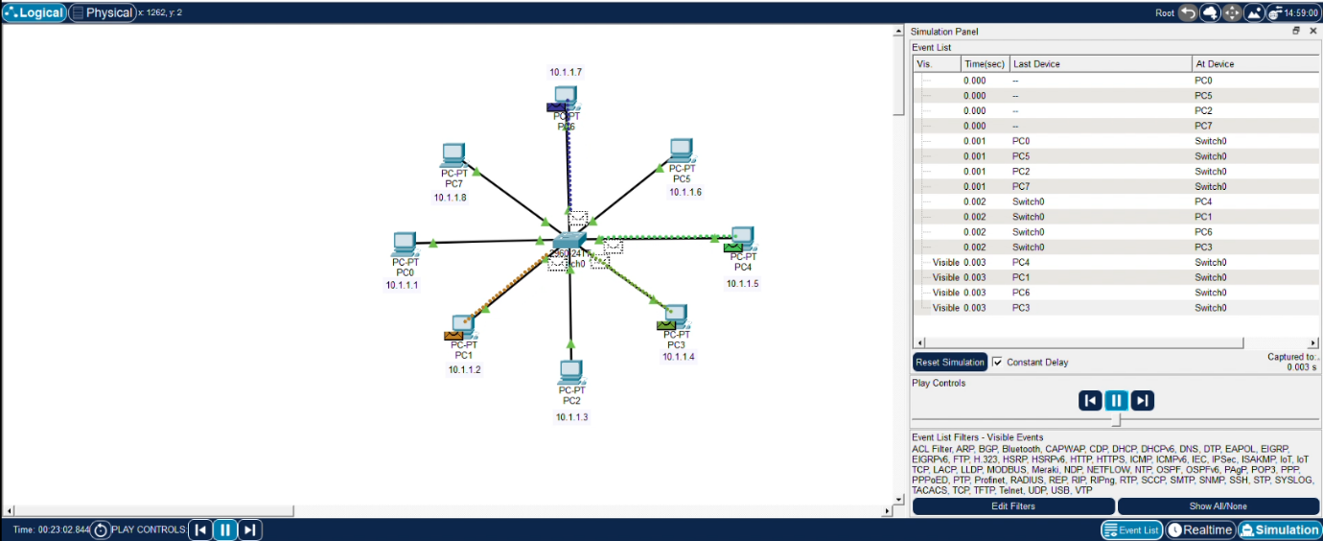

This image shows the Event List in the Simulation Panel of Cisco Packet Tracer, where packets sent from PC0, PC5, PC2, and PC7 are received by Switch0 at time 0.001 seconds. It indicates that these PCs are transmitting packets to the switch during the simulation. The switch acts as the central device that receives and forwards packets to the appropriate destination PCs. This event list helps monitor how packets move from end devices to the switch during network communication.
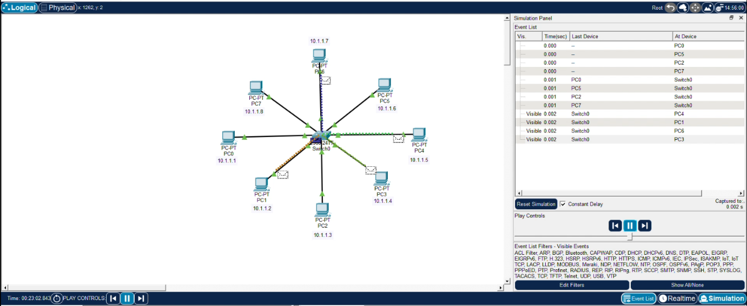

This image shows the Event List in the Simulation Panel where Switch0 forwards packets to destination PCs. At time 0.002 seconds, the switch sends packets to PC4, PC1, PC6, and PC3. This indicates that the switch has received packets from source devices and is now distributing them to the correct destination computers. It demonstrates how a switch forwards network packets within a LAN during ARP or ping communication.

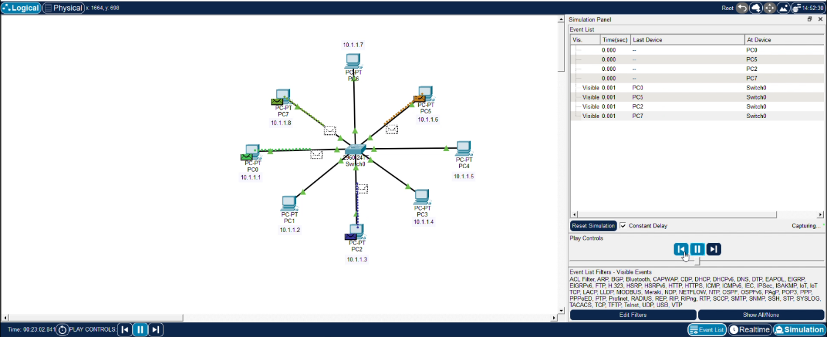

This image shows the Event List in the Cisco Packet Tracer Simulation Panel where PCs send packets back to the switch. At time 0.003 seconds, PC4, PC1, PC6, and PC3 transmit packets to Switch0. This indicates the response phase of communication, such as ARP replies or ICMP ping replies, where destination devices respond to the source through the switch. It demonstrates the two-way communication process in a LAN network.

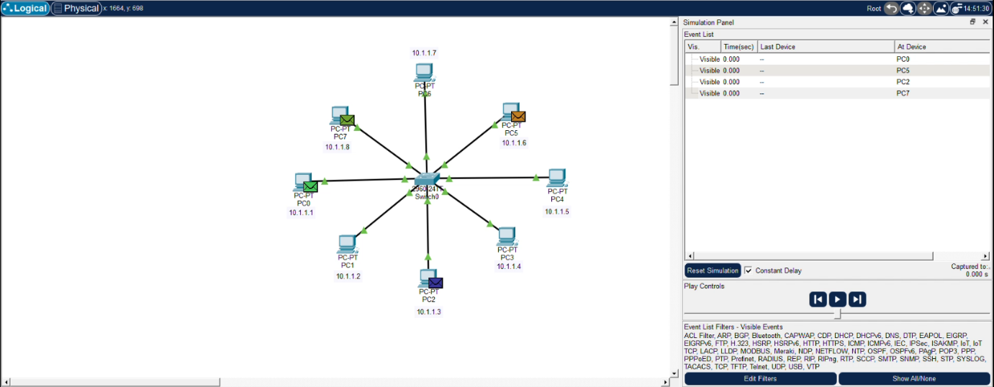

This image shows the Event List in the Cisco Packet Tracer Simulation Panel where Switch0 forwards packets to the source PCs. At time 0.004 seconds, the switch sends packets to PC0, PC5, PC2, and PC7. This indicates that the responses from destination devices have reached the switch and are being delivered back to the original sending PCs. It demonstrates the completion of communication such as ARP reply or ICMP ping reply in the LAN network.

8. Conclusion
This study demonstrated the implementation and working of Address Resolution Protocol using Cisco Packet Tracer. The experiment showed how ARP resolves IP addresses into MAC addresses to enable communication between devices in a LAN.
By observing ARP request and reply messages in simulation mode, students can clearly understand how devices discover each other's physical addresses. The experiment provides a strong foundation for learning advanced networking concepts such as VLANs, routing, and network security.

